**An Internship Report on**

** System Requirements Specification On Loan Application Management System (LAMS)**

**Submitted To**

**Mohammad Noor Nabi**

**Senior Lecturer**  
Department of Computer Science & Engineering

Independent University, Bangladesh

**Submitted By**

**Adiat Islam Sahih**

**ID: 1521582**

Internship Program

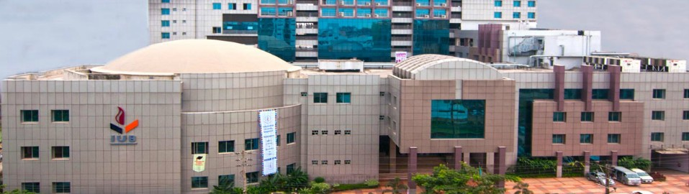 Independent University, Bangladesh

**Date of Submission: Autumn Semester**

Letter of Submission

**To,**

**Mohammad Noor Nabi**

**Senior Lecturer**

**Department of Computer Science & Engineering**

**Independent University, Bangladesh**

**Subject: Submission of Internship Report.**

Dear Sir,

You will be glad to know that I have successfully completed my internship program from Spectrum Engineering Consortium Ltd. which is a pre-requirement of CSE program. Spectrum Consortium Engineering Ltd. is one of the largest IT companies in Bangladesh to provide peace of mind and quality products and services to its value-oriented clients around the world. Spectrum has been a major player in the development of IT infrastructure in many industries in Bangladesh over the past 20 years. It was a great opportunity for me to get a chance to work in the organization as an intern.

While working as an intern, I also collected information for my internship report on the title of the report named “**System Requirements Specification on Loan Application Management System (LAMS)”** so that I can prepare and submit my internship report in time.

It would be very tough for me if I had not get the guidelines and support from you to prepare my internship report. The format of the report helped me to understand the report steps and to prepare such an extensive report. I want to ensure you that I have used all the valid and relevant information so that the report can portray a clear idea on loan management system.

I, therefore, pray and hope that your honour would be kind enough and accept my internship report and oblige thereby.

Sincerely Yours,

**Adiat Islam Sahih**

**ID: 1521582**

**Independent University, Bangladesh**

**Acknowledgement**

The acknowledgement starts with thanking my Almighty Allah for making me able to complete the 4 years of CSE program, to the opportunity to work in Spectrum Engineering consortium Ltd as well as to complete my internship report.

At first, I would like to show my gratitude to my honourable internship supervisor **Mohammad Noor Nabi, Senior Lecturer, Department of Computer Science & Engineering, Independent University, Bangladesh** for all the efforts he had shared beside his busy schedule. The internship outline and the guidance, I received from him, helped tremendously to prepare my report and to make my study a valuable one.

Secondly. I want to thank to my office supervisor **Saiful Islam Sumon, Software PM, Spectrum Engineering Consortium Limited** who helped me a lot to understand my intern responsibilities and helped me by providing relevant information. Without his supports and directional advices, it was hard for me to complete the study.

I want to thank all the employees and staff for helping to perform my responsibilities as an intern in Spectrum. They often shared informative ideas of Spectrum that helps me to gather data for the report. I am so grateful to all that they manages time for me during their busy schedule.

Table of Contents

**Tittle Page...................................................................................................................................… i Letter of Submission....................................................................................................................... ii Acknowledgements......................................................................................................................... iii Table of Contents..............................................................................................................................iv List of Figures.................................................................................................................................. v List of Tables....................................................................................................................................v**

**Chapter 1:**

**Introduction1**

**Background2**

**Objectives3**

**Scope of the project3**

**Background of the company4**

**Vision, Mission and Values 4**

**Product and Services5**

**Chapter 2: Literature Review**

**List of courses that helped in the development process 6**

**Chapter 3: Methodology7**

**Chapter 4: Project Management**

**Work breakdown Structure8**

**Gantt chart9**

**Chapter 5: Body of the project**

**Description of the work10**

**Main Modules of the System with functionality 11**

**Data dictionary 19**

**Testing 22**

**Chapter-6: Result and Analysis**

**Limitation of the study 23**

**Recommendations 24**

**Chapter 6: Future work and Conclusion25**

**References 26**

**List of Figures**

**E-R Diagram12**

**System Flow Chart13**

**Use Case Diagram (Admin Side)14**

**Use Case Diagram (Customer and Visitor Side)15**

**Activity Diagram (Admin Side)16**

**Activity Diagram (Customer Side)17**

**Class Diagram18**

**Output Loan application Details21**

**Loan Details21**

**List of Table**

**Loan application 19**

**loan_master18**

**Activity Diagram (Customer Side)17**

**Class Diagram18**

**Executive Summary**

Internship is a pre-requirement of **Independent University, Bangladesh** to achieve Computer Science & Engineering (CSE) degree. Students have to go through a practical working experience inside a real organization where they need to learn how a real organization works by working as an intern for three months.

It was a great opportunity for me to attain the intern opportunity in Spectrum Engineering Consortium Ltd. as it is one of the largest IT companies in Bangladesh to provide peace of mind and quality goods and services to its value-oriented clients around the world. Spectrum has been a major player in the development of IT infrastructure in many industries in Bangladesh over the past 20 years.

During the internship period I have learned and observe how the company promote itself to the Bangladeshi market as well as to the abroad. So, this how I meet my educational experience with the real life experience.

The report is concentrated on Loan Application Management System under one of the largest IT company of Bangladesh and deliver the ideas how the company called Spectrum Engineering Consortium Ltd promotes the company into the Bangladeshi and international market. The First chapter is going to share the basic ideas of this report that includes information about IT industry, scope of the report, core objectives and limitations of the report. The Second chapter is the methodology part of the study and the Third chapter is going to portray Project Management. Most importantly, in the Fourth chapter, details of the project

Last but not least, in the fifth chapter I have shared some limitation of the study and some suggestions.

**Chapter 1: Introduction**

**Background**

Loan Management System (LMS) is the most practical application developed to keep record of all the customer lending records, fund flows, customer records and cash flow. Any Non-Banking Financial Company (NBFC) or bank will need a Loan Management System to set up the loan product and perform client servicing. To accurately calculate the part of each payment that is to be applied to principal, late fees, interest, etc., a loan management system is required. It also comes with the benefits of an extensive report suite including monthly billings, loan payoffs, property tax renewals, accounting reports, account history, late notices, property tax renewals, promises to pay and many interest statements. A detailed report on the customer’s financial position is maintained by the loan processing system. All types of loans including balloon payments, standard mortgages, and interest only loans, etc. are handled by it. By regulating the business activities and maintaining proper lending and financial records, it simplifies the transactions. Various modules including loan tracking, lender module, mortgage module, deed of trust software, lending module, etc. can comprise a loan management system. A loan management software system manages the loan information and the store or database. This data stored is used for cash flow information, tracking current instalment payment status, loan servicing and other accounting tasks. To manage portfolio of loans and keep up with the financial data necessary is the basic purpose of such system. Some important features of this system must include create amortization schedules, sharing of principal, interest and late charge payments between two entities, charge/collect late fees, ability to handle conventional and non-conventional financing, accurately track partial payments, user friendly, powerful, affordable and fully featured. This type of software program has a great impact on lender companies as the program is dynamic and flexible in nature. Investors, not-for-profit organizations and investors, all can extract some good from this. It builds some strong long-term client relationships.

**Objectives**

The main objective of building this product is to develop a lightweight, user-friendly, flexible and efficient loan management system. Availability of data is a key to ensuring good governance in Loan Administration so that customers can be served as well as the interests of the bank can be fulfilled properly. It is the responsibility of Loan Operations to ensure all customer requests are catered to and proper traction and follow-up on completing securing documentation can be ensured in a faster yet effective manner to protect the bank’s interest. As such, enhancements to Loan Application Management system are required.

**Scope of the project**

I made this report only for academic purposes and to fulfil the requirement for industrial attachment. In this report, I try to cover the direct and indirect aspects of the software industry and its challenges. The report on revealing howSpectrum Engineering Consortium Ltd will highly effective to share knowledge of how a Bangladeshi IT company executes their promotional activities to their target and potential market. The marketing department of Spectrum can improve their communication strategy though the recommendation of the study. Other competitor of Spectrum can know the promotional activities performed by Spectrum as well. This may help them to improve their development policy too. Most importantly the study will help to the university students and faculties to compare the educational learnings with the real life experiences of mine.

**Organizational Background of Spectrum**

The Spectrum Engineering Consortium Limited is one of the largest IT companies in Bangladesh that provides quality and tranquillity to standards-based customers around the world. Over the last 24+ years, pioneer developer of Spectrum IT infrastructure in many sectors in Bangladesh. Its goal is to analyse customer demand and provide the best solution for the market. Spectrum Engineering Consortium Limited is one of the leading system integrators in Bangladesh. Since 1995, he has served more than 900 customers locally and globally. More than 200 long-term qualified partnership facilities with sophisticated technology Association with the company Such as Oracle, Microsoft, Cisco, Emerson, VMware, NetPassion, Jenband, etc. With the co-ordination of all these companies, Spectrum has developed its portfolio around the world.

# **Vision**

The Vision of Spectrum Engineering Consortium Limited is "Being a respected Bengali company all over the world by combining human and technological skills to create value for businesses.”

# **Mission**

The mission of Spectrum Engineering Consortium Limited is to provide the convenience of infinite information flow through innovative ICT infrastructure and services to organizations of all over the world.

# **Values of Spectrum**

To be a globally recognized company, Spectrum has set some policy and values. These are given below:

* Promote an environment where new ideas and creativity are cultivated and opportunities are the engine of success for our employees.
* Exceeds the expectations of the clients for the timely delivery of the budget.
* Commitment to innovation and improvement to ensure the creation of value for customers.
* We constantly strive to improve, strengthen our equipment, services, and products.

# **Products and services of Spectrum**

Spectrum provides the organization's several kinds of IT services. It helps with analysing vertical solutions with large amounts of data to display real-time data, which are used to create new data. Spectrum can develop and design real-time analytical solutions with or without the data warehouse and an offline analysis platform.

Spectrum has a long history and experience "real-time business accelerators in real time" that integrate data analysis, analysis, and modelling and predict the basis of its celebrated trend, create visual analysis/visualization in real-time "real-time" monitoring for the main business index. Spectrum is able to design and size changeable solutions that handle all of the huge amounts of data sources Inclusion of retarding system, the applications, and social sources, data warehouses and data network or passing information between the registers lines.

Through its extensive experience on the Bangladeshi Financial Sector, Services and Public Communications, Spectrum offer its customers the best mathematical domain analyst, model, database of statistical models of the domain, default domain information, maths and neutral models, and the state of the art visualization are the services the company is providing to their customers.

**Chapter 2: Literature Review**

**List of courses that helped in the development process**:

• CSE 303, Database Management: This was the first course which taught how to design and plan a project. It covered popular planning and strategy practices such as System Development Life Cycle, Rich Picture, Requirement Analysis, Entity Relationship Diagram, Business Process Model and Notation Diagram and many more.

• CSE 307, System Analysis and Design: This course gives an overview of different SDLCs and how to adopt each one of them to the project.

• CSE 452, Software Marketing: This course gives an overview Introduction to marketing and marketing communication, service marketing, marketing challenges of technology products and services, intellectual property management, advertising and product management.

**METHODOLOGY OF THE STUDY**

Approach of the study considers, theoretical examination of the procedures associated with a field of any examination. It contains the speculative examination of the gathering of methodologies and principles related with a branch of data. Typically, it incorporates thoughts, for instance, perspective, theoretical model, stages and quantitative or emotional procedures. Here system is associated full effectively.

Research Type: This is a Descriptive Research, which briefly uncovers the general exercises of SCB and furthermore fundamentally examines the "Loan Management" of this bank. To set up this report all the fundamental data gathered from both essential and auxiliary wellsprings of information.

Primary Data Collection:

* Interviews with RM Officer.
* Observation.
* On the job trainings.
* Practical working experiences.

Secondary Data Collection:

* Annual Report of SCB.
* News articles of Security issues.
* Website of the SCB.
* Different website information
* Related news articles

Data Analysis and Reporting:

Both the qualitative analysis (interview) and quantitative analysis (annual report )have been utilized to gather and dissect the assembled information.

Chapter 4: Project Management

Work breakdown Structure

In Loan Application Management System

* Development of the SRS of the system.
* Development of the overview of the system.
* Development of monetization plans.
* Design and development of Data Flow
* Development & UT of APIs, Admin & Settings Modules
* Specificationand finalization of Security Requirements
* Development and specificationof Quality and Testing Requirements
* Design and resource gathering phase
* Development & Unit testing of all modules
* Development & UT of APIs, Admin & Settings Modules
* Development & UT of Security Modules
* Integration and configuration
* Bug fixing and issue resolution
* Finalize Development and UT

|  |  |  |  |  |  |  |  |  |  |
| --- | --- | --- | --- | --- | --- | --- | --- | --- | --- |
|  | **Development**  **Phase** | **80 Days** | | | | | | **Duration**  **( Day )** |  |
| 0 to 10  Day | | 10 to 20  Day | 20 to 30  Day | 30 to 40  Day | 40to 50  Day |
|  | **Requirement**  **Gathering** |  | | | | | | **03** |  |
|  |  | | | | |
|  | **Analysis** |  | | | | | | **6** |  |
|  | **System Design** |  | | | | | | **15** |  |
|  | **Coding** |  | | | | | | **20** |  |
|  | **Testing** |  | | | | | | **5** |  |
|  | **Implementation** |  | | | | | | **03** |  |
|  | **Documentation** |  | | | | | | **Parallel** |  |
|  | **Total Time (Days)** |  | | | | | | **50** |  |

**Gantt chart**

Gantt chart with Resource Allocation and Activity wise Time Distribution

**Body of the project**

**Description of the work**

* Interest rates and the loan details are also available at the click of a mouse.
* Customer can apply for a loan and after approved it they can track their details from online.
* This system provides detail about the customers, their loan details, EMI details and its rate details.
* System provides download option to download different type of loan form in MS word document.
* Using with this system admin can find customer easily and it’s a paperless system so workload is reduced.
* The decision process becomes faster and more consistent.
* After registration and login customer can use the system easily and also customer can view any query about loan details as well as EMI details in their profile. So this system saves time.
* Provides good communication for the customer
* In this system there are used EMI (Equated Monthly Instalment) calculators.
* Provides a facility to generate the reports very easily.

#### **MAIN MODULES OF THE SYSTEM WITH FUNCTONALITY**

#### **There are Following Modules of this System:-**

* **User management:**

Registration:

Customer, User can registration with basic information like User name, Mobile no, email id etc.

Login:

Admin, Users can login with username and password.

Manage Profile:

Admin, User can manage profile and update information.

* **Loan Application:-**

Admin manage loan application which is sent by customer using the system.

* **Download Loan Form:-**

Once loan is approved customer can download loan form in MS word document to sign of them and their guarantor.

* **Customer Information Module:-**

It shows all an information & details of the customer database which includes all the details like customer name, address, contact no, bank account no, PAN no, email id, etc. Only Admin can manage customer record.

* **Loan transaction module:-**

Loan transaction module includes Loan Type, Customer, Issuing Loan, EMI Calculation, Receive payments. The System Administrator can able to add, modify loan type like Home Loan, Gold Loan, Personal Loan of customer

and can modify the interest rate.

One customer can have more than one loan, System generate unique loan no. Admin can add, modify loan details like loan type, loan amount, tenure, mortgage details, guarantor details.

EMI Calculation - System have EMI calculator which can provides details of particular loans, System take input from user like Loan Amount, Interest Rate, Tenure, Issue Date and give details output like monthly EMI, total interest, total cost.

Receive payment – using with this System admin can enter payment information for particular EMI, in this system late fine charges can mention if receipt date is greater than the EMI date. System user can find customer by their name to get customer ID

**A Query Module:-**

* + - * It shows EMI Payment details
      * A query module give information for particular customer, Customer user can search information by entering customer ID.
      * It displays details like No of payment, EMI amount, EMI date, Receipt date ,Late fine charge if any etc.

### User

There are main two users:

1. Admin

2. Customer

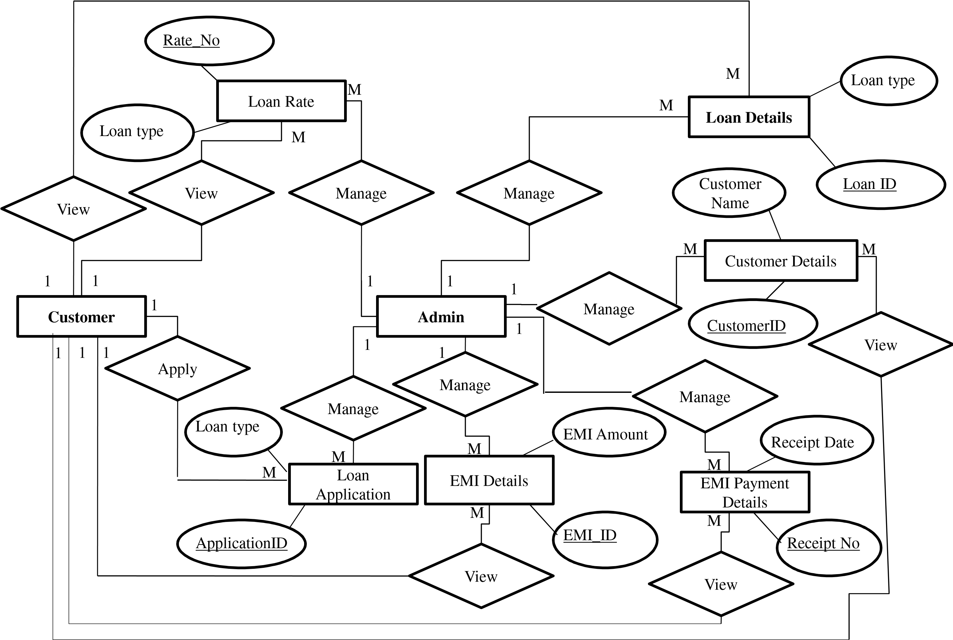

Figure**: E-R DIAGRAM**

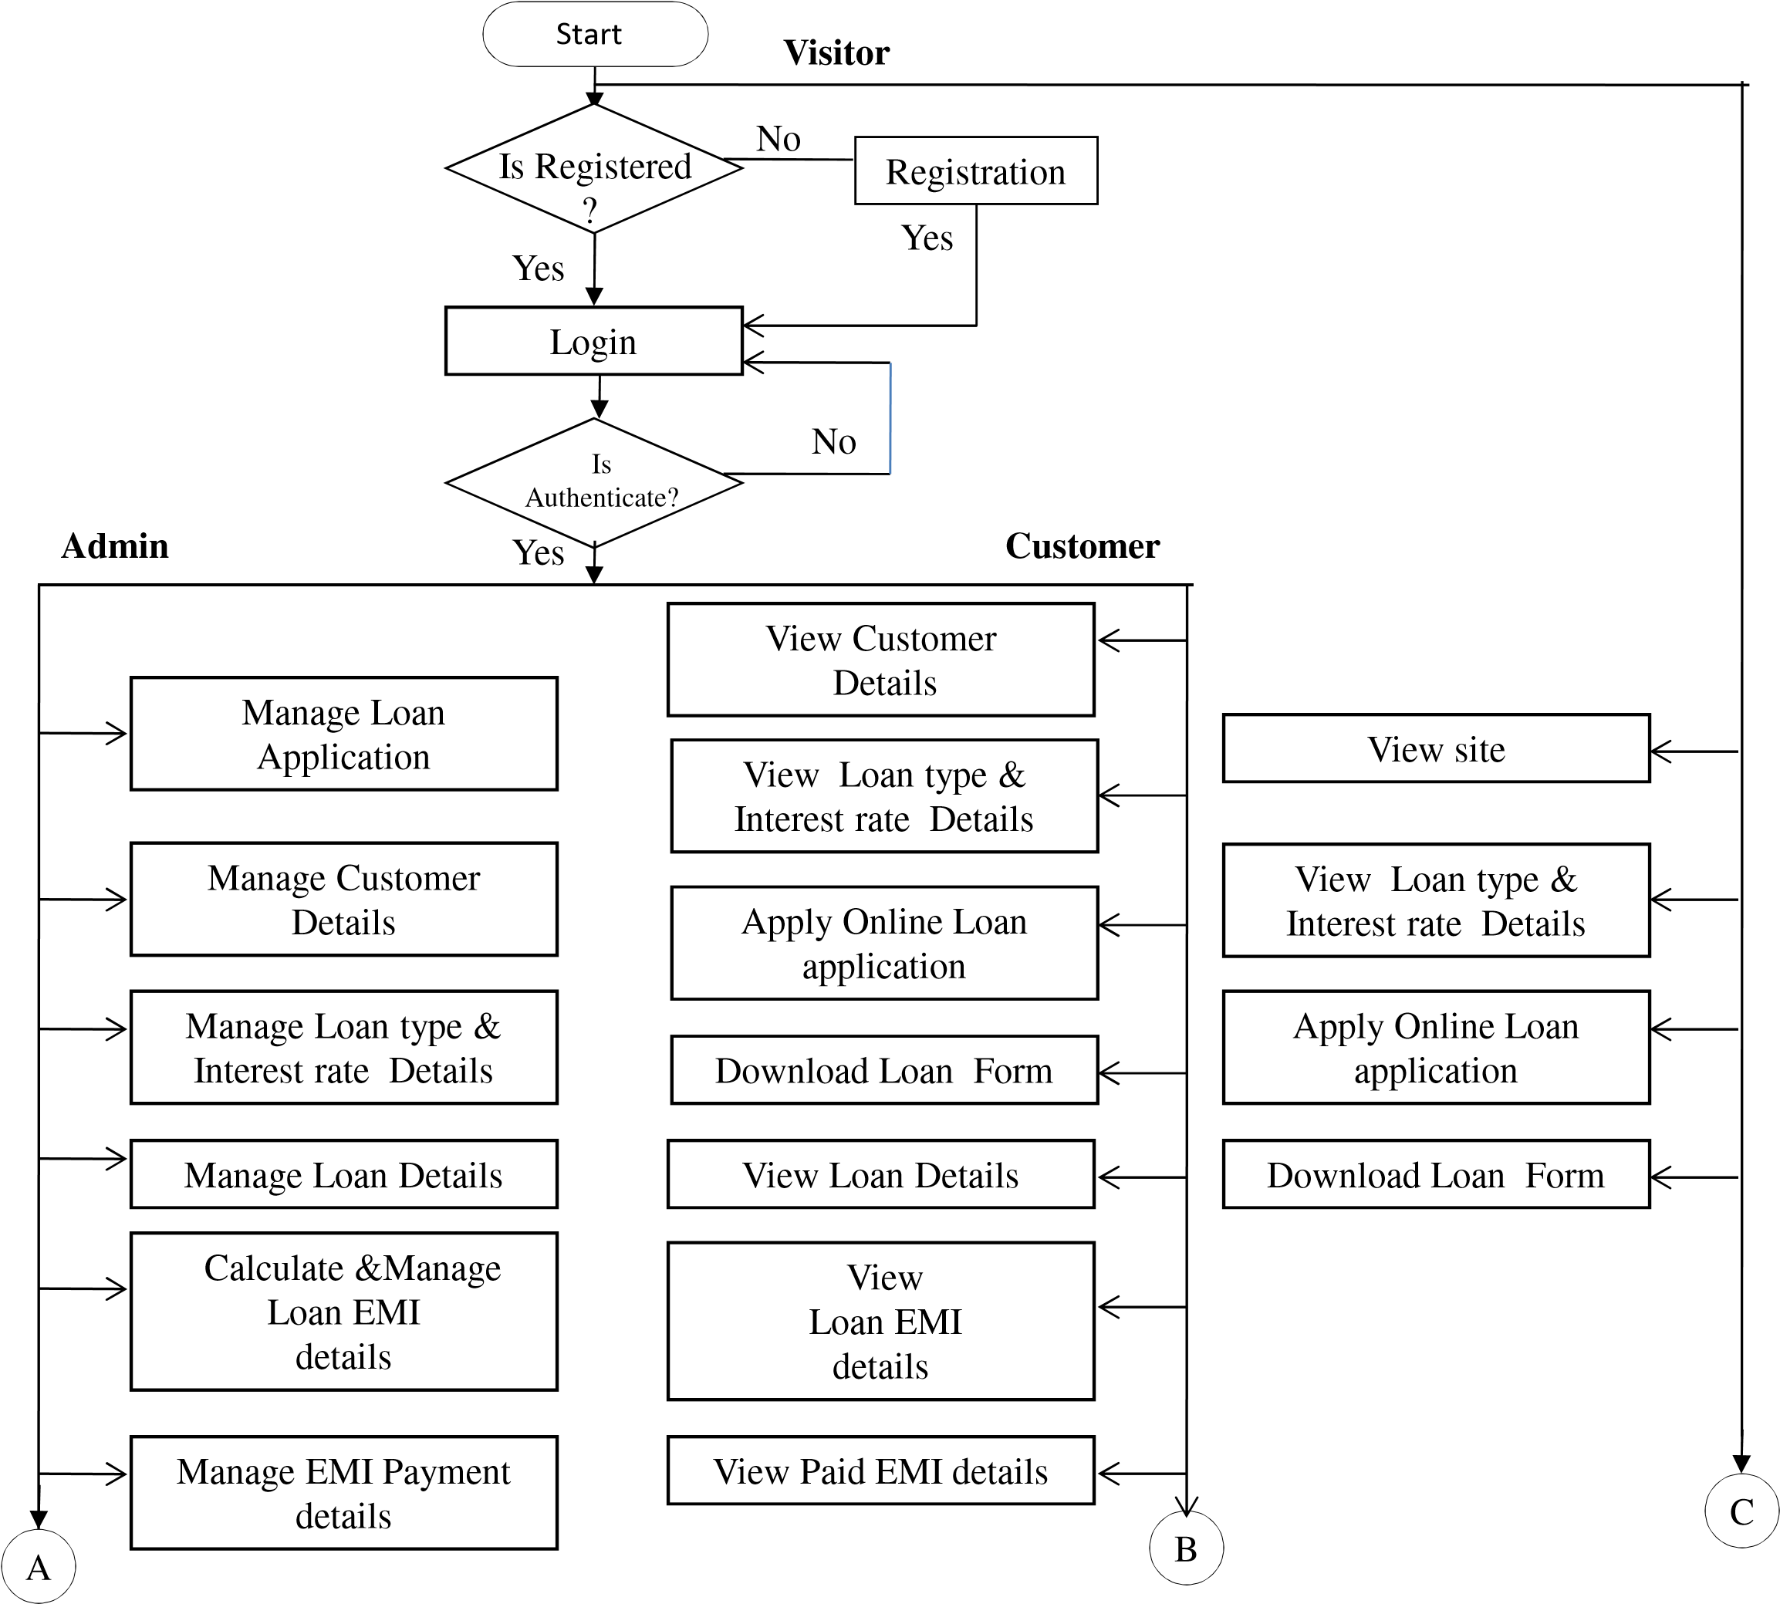**SYSTEM FLOW CHART**

Generate Report

Show Report

C

Stop

Logout

B

A

**USE CASE DIAGRAM**

**Admin Side :**

**Admin**

Manage

User

Manage

Loan

Manage

Loan Type

Manage

EMI Detail

Manage

Report

Manage

Interest rate

Logout

Login

**Customer and Visitor Side**

**Customer**

Visit

site

Login

Manage

Profile

Loan

EMI Detail

Paid EMI

Detail

Manage

Loan Detail

Interest Rate

Detail

Apply online

Loan Form

Download

Form

Logout

**Visitors**

**ACTIVITY DIAGRAM**

Login

Manage all User

Manage Loan

Type/Interest Detail

Manage EMI

Payment

Logout

No

Yes

Valid User

Manage EMI

Calculation

Manage Report

**Admin Side :**

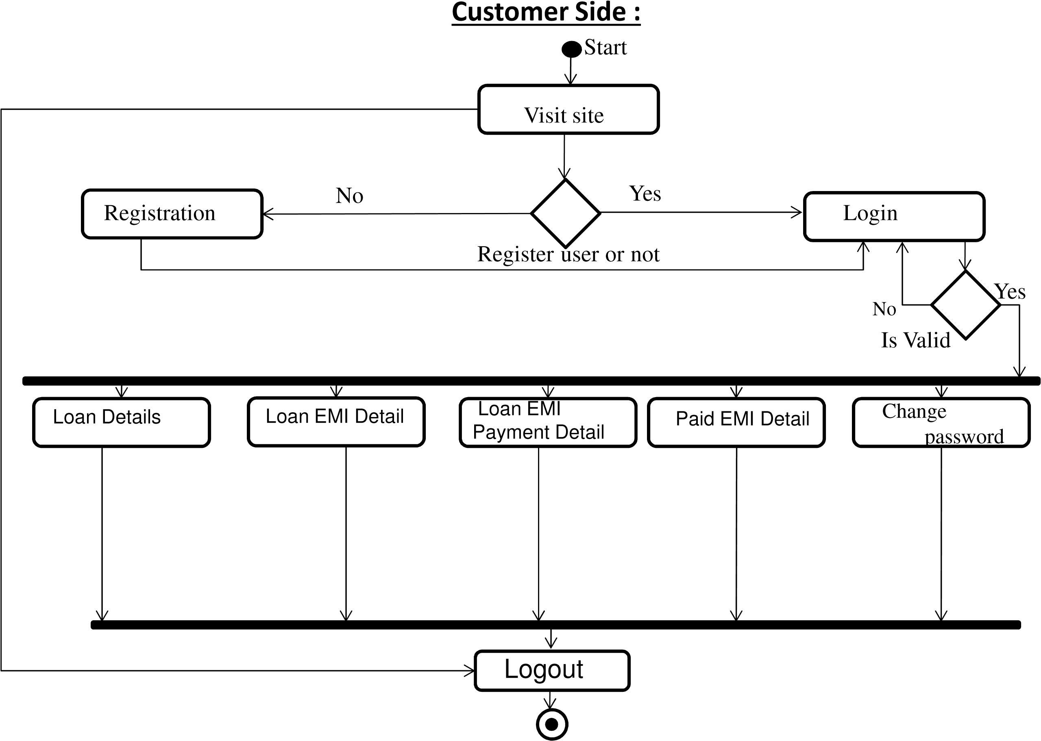

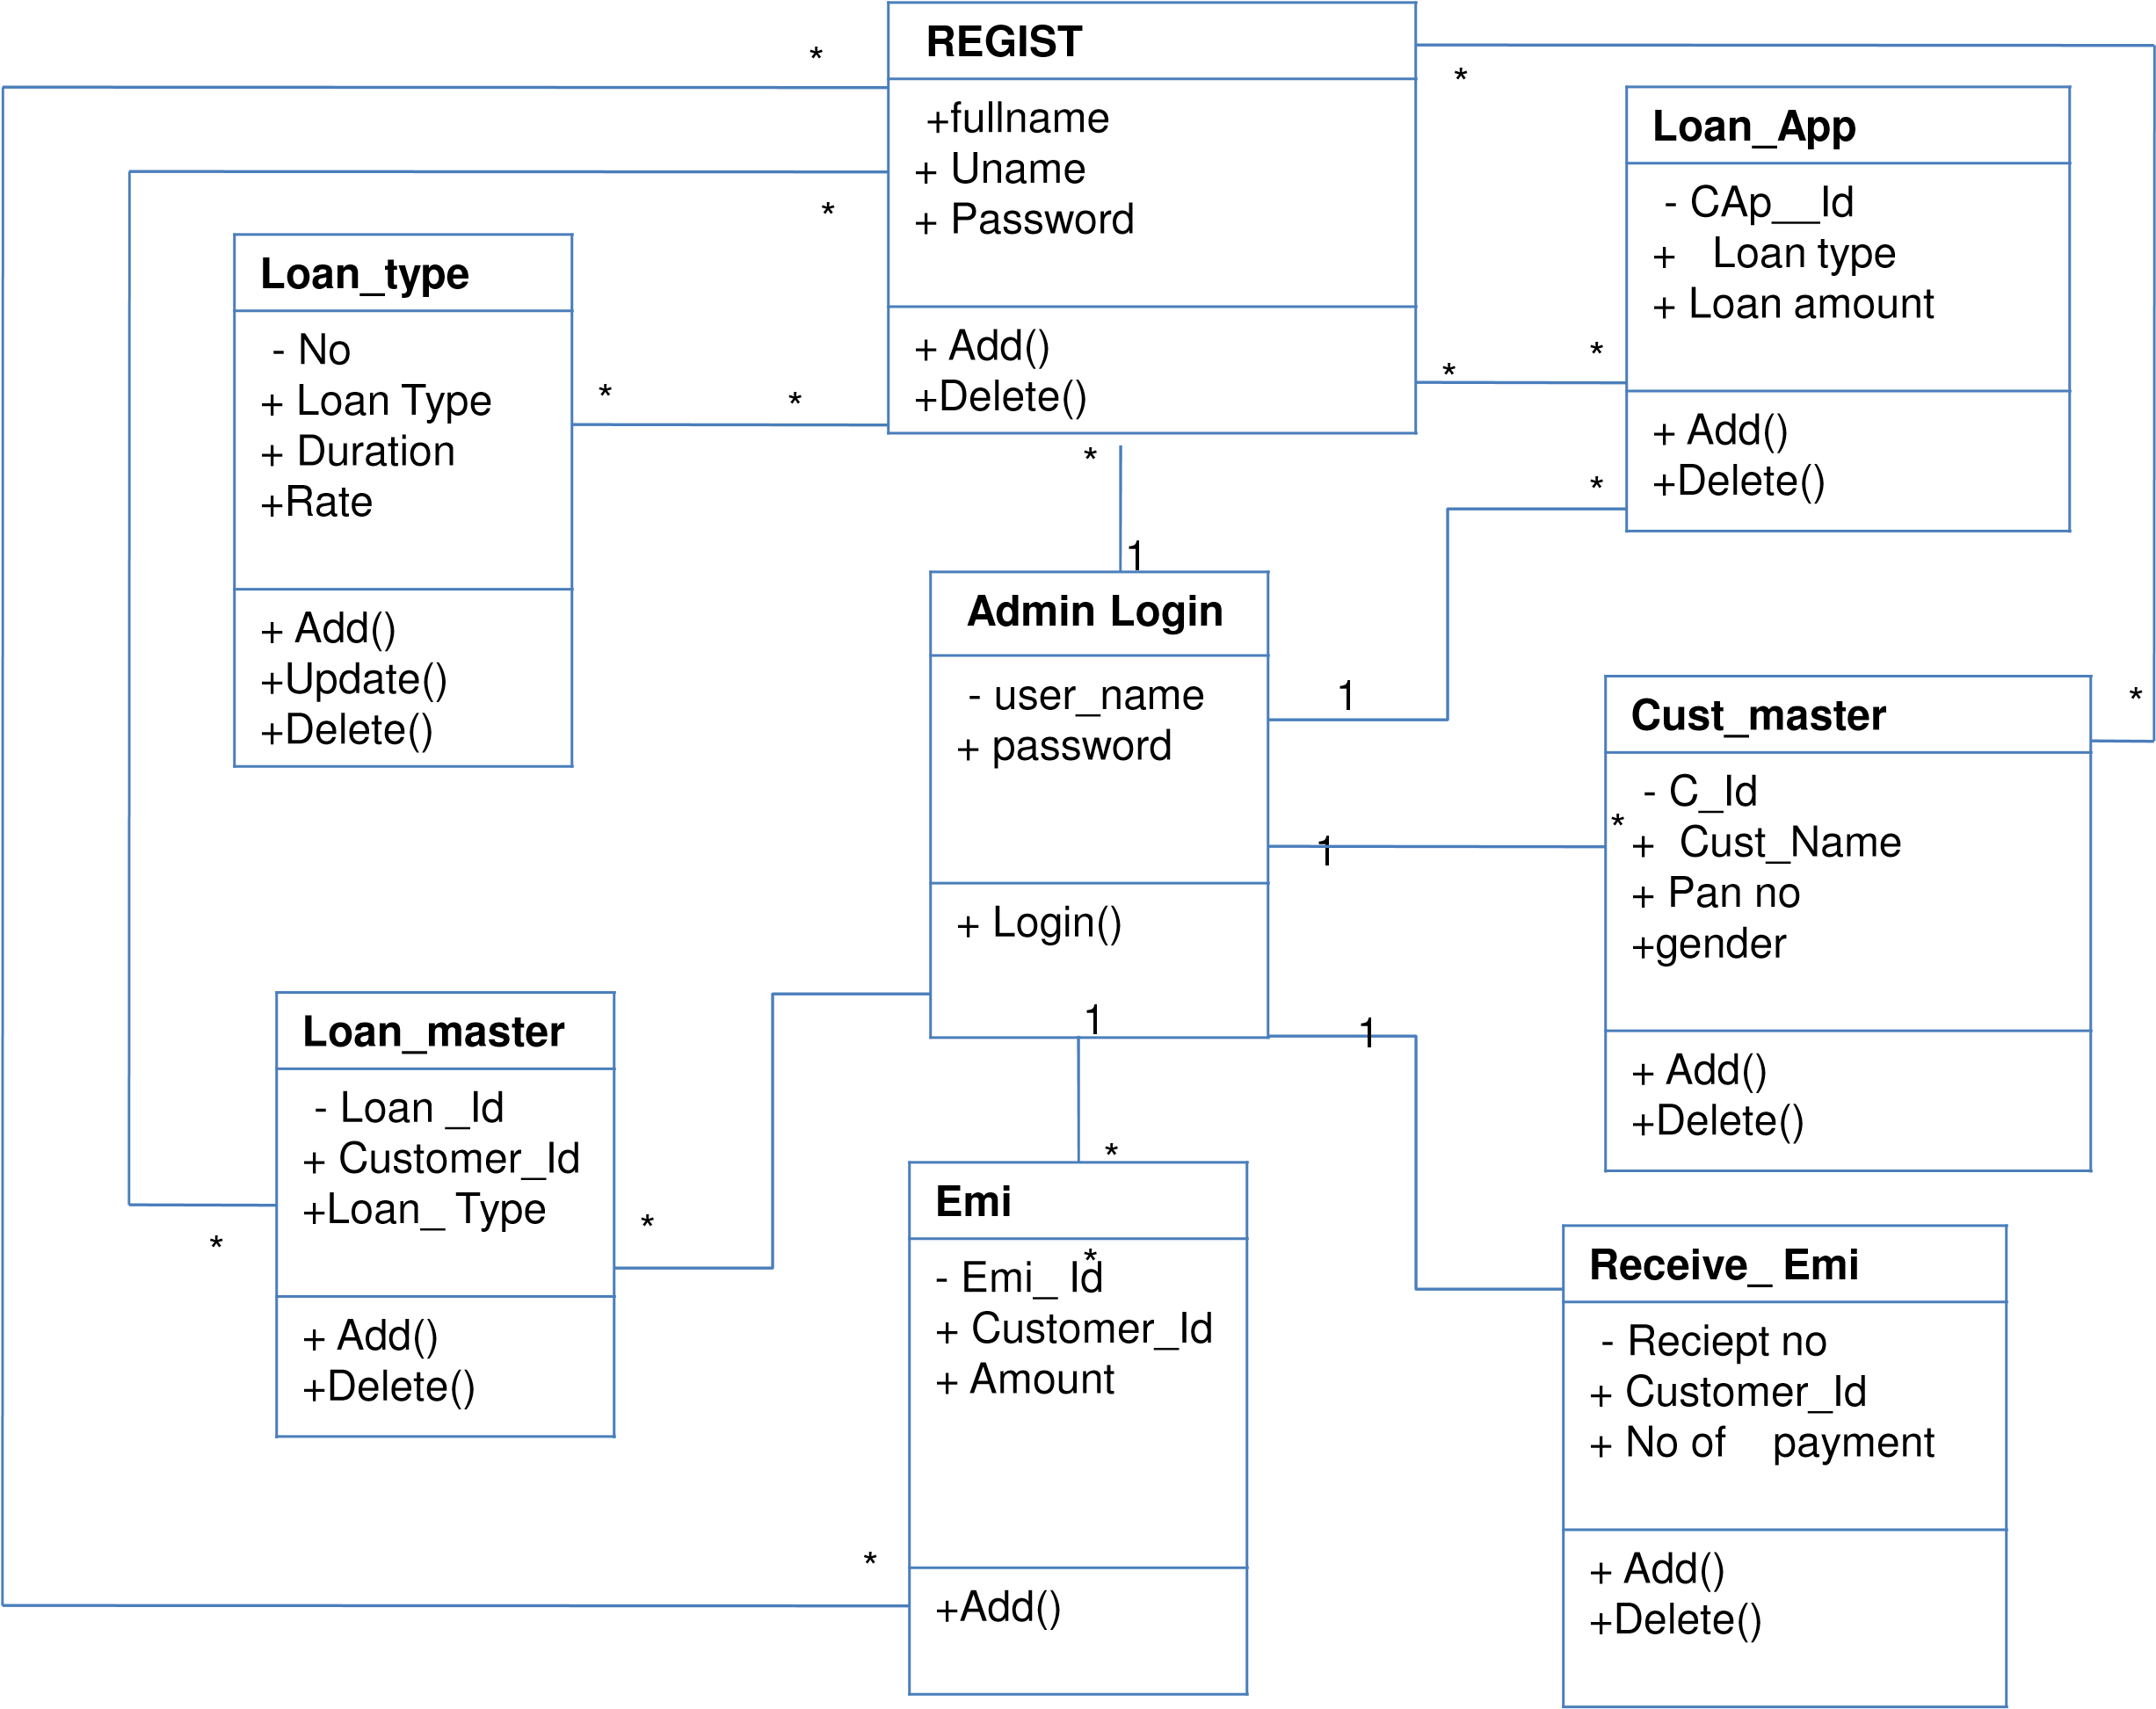**CLASS DIAGRAM**

**DATA DICTIONARY**

1. loanapplication
2. regist
3. admin_login
4. fixed
5. float
6. Cust_Master
7. Loan_master
8. emi
9. receive_emi

**Table Name : loanapplication**

**Primary Key :** app_id

**Description :** Admin can manage loan application Details which is sent by customer

|  |  |  |  |  |
| --- | --- | --- | --- | --- |
| **Sr.No** | **Field Name** | **DataType(Size)** | **Constraint** | **Description** |
| 1 | App_id | Int(4) | Primary key | Store Employee ID(Auto increment) |
| 2 | Loan_Type | Varchar(15) | Not Null | Store the name of loan like Home loan ,gold loan ,Personal Loan,Vehical Loan. |
| 3 | Loan_Amount | int(12) | Not Null | Store amount of loan |
| 4 | Cust_Name | Varchar(20) | Not Null | Store the name of customer |
| 5 | Monthly_Incom e | int(6) | Not Null | Store the monthly income of customer |
| 6 | Gender | Varchar(6) | Not Null | Store gender of customer |
| 7 | Age | int(2) | Not Null | Store age of customer |
| 8 | Address | Varchar(50) | Not Null | It store an information about Address. |
| 9 | MobileNo | Numeric(12) | Not Null | Store the Employees Mobile Number |
| 10 | WorkPhone | Numeric(12) | Not Null | Store other phone number of customer |
| 11 | EmailID | Varchar(30) | Not Null | Store Email Id of Customer |

**Field Name**

**Sr.No**

**Datatype(size)**

**Constraint**

**Description**

Primary key

1

Loan_ID

Int(4)

Store loan

id (auto increment)

Foreign

id

It gives references to the customer

key

2

C_ID

Int(4)

3

Loan_Type

Varchar(30)

Not Null

Store

the type of loan

int(2)

Not Null

Store

the tenure of loan

4

Loan_Tenure(Months)

5

Loan_Amount

of loan

Store amount

int(12)

Not Null

Interest_Type

6

Store

the type of interest like float or fixed

Varchar(10)

Not Null

7

Interest_Rate

float(4,2)

Not Null

Store

an interest rate of loan

Varchar(10)

customer

Store the date of given loan to

Not Null

8

IssueDate

Null

Varchar(50)

9

Mortgage_Details

details of customer

Store the mortgage

10

Guarantor_Name

Varchar(30)

Not Null

Stores the customer’s guarantor name

e

11

Address

Varchar(50)

Not Null

It store an information

about customer guar

antor add.

12

ContactNo

Varchar(30)

Not Null

Store the

guarantor contact number

**Table Name :**

**loan_master**

**Primary Key :**

**Foreign Key:**

Loan_ID

C_ID

**Description :**

Admin can manage customer loan details

35

Loan application details

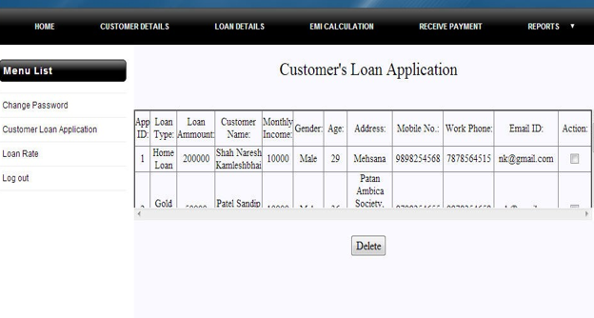

Loan details

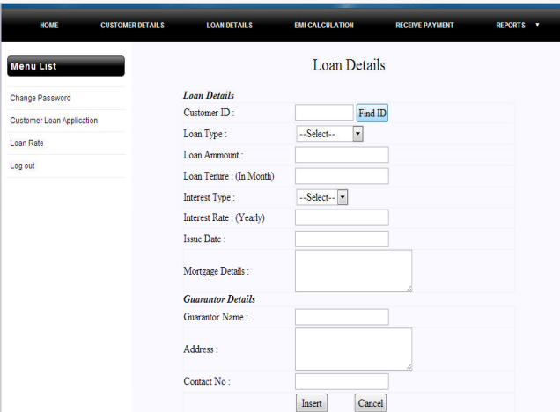

**TESTING**

|  |  |  |  |  |  |
| --- | --- | --- | --- | --- | --- |
| **No** | **Test Cases** | **Case Type** | **Expected Result** | **Actual Result** | **Pass/Fail** |
| 1 | Admin Login | 1.Wrong User Name  And Password | The system displays an Error Message, prevents from Login. | The system displays an Error Message “Invalid User Name or Password”, prevents from Login. | Pass |
| 2. Enter Correct User  Name And Password | The system updates Session variables and redirect to home page. | The System Display Home Page for User/Admin. | Pass |
| 2 | Admin | 1. Company Admin | The System can Redirect the Page. | The System Display All Pages for Admin. | Pass |
| 2. User Detail | The System can Redirect the Page. | The System display to the all user details. | Pass |
| 3. User Type Master | The System can Redirect the Page. | The System display to the all user type master | Pass |
| **No** | **Test Cases** | **Case Type** | **Expected Result** | **Actual Result** | **Pass/Fail** |
| 5 | Customer Login | 1. Non-Registered User | The System will not allow  Non Registered User to Login. | Non-Registered user can’t Login. | Fail |
| 2.Wrong User Name  And Password | The system displays an Error Message, prevent from Login. | The system displays an Error Message “Invalid User Name or Password”, prevents from Login. | Pass |
| 3. Enter Correct User  Name And Password | The system updates Session variables and redirect to home page. | The System Display Home Page for User/Customer. | Pass |
| 6 | Customer  Registration | Enter null in mandatory  fields | It will not add the detail | It will show message that enter the data. | Pass |
| Enter incorrect data | It should not let add the  Enter Product. | It will show message that enter the correct data. | Pass |
| Enter correct data of all required field | It should let add the Enter  Correct Detail. | It will show the message of Add Detail. | Pass |
| 8 | Loan Details | Enter customer loan details. | There will not add other detail. | There will provide customer‘s loan details. | Pass |
| 9 | EMI details | Enter loan amount +  Tenure + rate. | There will not add other detail. | There will provide all calculated EMI details. And also it can be store | Pass |
| 10 | Receive payment  details | Enter customer’s receive EMI payment details. | There will not add other Detail. | There will provide customer receive payment details. | Pass |

Result and Analysis

This section provides an assessment on the result of the project based on the defines requirements that have been mentioned earlier in the project objectives.

Functionalities

Authentication The authentication section has achieved all the requirements mentioned. Every web page request made must first authenticate the user or else the user gets directed to the login page.

Additional requirements that were achieved include:

• Authentication tokens are saved using cookies.

• Users are required to have an account to be issued an access token and a refresh token. Invalid accounts will show the response message error description. Username in-puts remove capitalize letters and spaces when the request is sent.

**Qualities**

The quality requirements of the project have been achieved. Quality check is done by the project leader with each new implementation in the modules. The LMS has achieved the following quality requirement:

• The system should have an attractive, uncluttered, simple user interface with readable font-size and font-style.

• The system must not cause any crash or freezes to the browser. There must not be any shuttering while scrolling and the loading speed of each view are reduced to a minimum. React greatly reduces the loading time for each section as it only loads the parts that have been modified. Web pack provides the advantage of bundling modules into a minified file which improves performance.

• It should be responsive on both the web browser and the mobile browser.

# **Limitations of the study:**

Several problems I have to go through while preparing the report. Collecting and acquiring data was found very hard for me as there were lack of information, publications, and annual reports of Spectrum Engineering Consortium Limited. The limitations are listed below:

1. **Confidentiality:** As an IT company, Spectrum maintains high security to most of their inside organization and interns are highly requested not to show confidential information in their study from the beginning of the internship program at Spectrum.
2. **Lack of noteworthy resources:** Spectrum do not publish their annual report and there are almost no information exist in the web except their own websites.
3. **Short period of time:** Creating this extensive internship report in this 2.5 month duration and at the same time performing all the intern responsibilities at Spectrum was very tough.
4. **Worldwide pandemic of COVID19**: This was the hardest challenge that had to be tackled as the office had to be closed down and everyone had to work remotely, this led to the possibility of a lack of communication. Thankfully, there were regular meetings, that had to be attended, pair programming, issue reporting, to avoid the possibility of a lack of communication.

# 

# **Recommendations**

After analysing my work, I have found few challenges and threats of Spectrum Engineering Consortium Limited that need to overcome immediately. This chapter will deliver few suggestions based on my theoretical learning from IUB so that the IT Company can improve its promotional mix and sustain its business in this competitively growing industry.

1. The current market is so competitive. For example, Spectrum should promote its products and services to consumers through a variety of promotional tools to link Spectrum's presence and difference points with target customers and to maintain and search for potential customers.
2. The promotional activities are found very limited. A strong communication strategy should be built to become a key player in the market.
3. Spectrum can look for a strategic alliance with an ascending or descending party. This means facilitating competition to create a consortium with another organization, in particular, to expand the network infrastructure at the national level, as well as for GP, Banglalink, Fiber@Home, and Summit Communication Ltd.
4. Advertising on newspaper or television should be concentrated as most of the competitors of Spectrum are utilizing those media. Moreover, the company doesn’t offer sales promotion or discounts as well. It is not very late that the company has to generate ideas to promote its products through these promotional activities.
5. Spectrum focuses on the quality of the service instead of the price of the services. As a result, the price of the spectrum is higher than that of the competition. To keep existing customers and attract new customers, Spectrum should offer some other value-added services (VAS) such as IP telephony, IP-TV, free email account, free or more affordable domain hosting with Internet / Intranet service.

Future Work and Conclusion

**Future Work**

* I will make online EMI payment to company.
* I will also make live chat with the client.
* I will also make live chat with the newsletter mailing system for user.
* I will also add news subscription field. Add online transaction.
* Add email facility.
* Add SMS facility.

Conclusion

This internship was very successful for me. The title of this internship report was very helpful to understand and apply my software specification knowledge in practical situation. I have gained new knowledge, skills, and met so many new people. I got insight into professional practice. The internship was also good to find out what my strengths and weaknesses are. This helped me to define what skills and knowledge I have to improve in the coming time. Since, I worked with a developer’s team in Spectrum. Now I know how to work with the team in a software company and how to communicate with other team members doing the project work together with time limitations. The experience, I have gathered, while preparing the report was precious and I can realize that this promotional mix learnings will help me to determine how to build and showcase a particular brand among the target customers so that I can create a compassion of my products and services to them.

Reference

Websites :-

1. www.javatpoint.com
2. www.sun.java.com
3. www.javaworld.com
4. www.stackoverflow.com

Books :-

1. Code Notes for J2EE : Robert McGovern
2. Java for the Web with Servlet & JSP : Budi Kurniawan
3. Professional Java Server Programming : Cedric Beust et
4. Sams Teach Yourself J2EE : Martin Bond